Sample Project Approach (Roadmap)
Title: Data Storytelling Techniques for Interactive Decision Analytics
Domain
Business Analytics
Dataset
I recommend using FOUR benchmark datasets together:
- Supermarket Sales Dataset
https://www.kaggle.com/datasets/wellkilo/supermarket-dataset?utm_source=chatgpt.com
- Global Superstore Dataset
https://www.kaggle.com/datasets/fatihilhan/global-superstore-dataset?utm_source=chatgpt.com
- Superstore Dataset
https://www.kaggle.com/datasets/mananapatel99/superstore-dataset-2014-2024?utm_source=chatgpt.com
4. Online Sales Data
https://www.kaggle.com/datasets/samruddhi4040/online-sales-data
All the are famous Valid Datasets. All are to be considered in the Project.
Data Analytics
• EDA
➔ EDA Flow Diagram:
Raw Dataset
│
▼
Dataset Overview
│
▼
Data Quality Assessment
│
▼
Descriptive Statistics
│
▼
Missing Value Analysis
│
▼
Duplicate Record Analysis
│
▼
Data Type Validation
│
▼
Outlier Detection
│
▼
Univariate Analysis
│
▼
Bivariate Analysis
│
▼
Multivariate Analysis
│
▼
Correlation Analysis
│
▼
Customer Segmentation
│
▼
Time-Series Trend Analysis
│
▼
Feature Engineering
│
▼
Feature Selection
│ ▼
Machine Learning Models

Preprocessing
- Missing Value Handling
- Duplicate Removal
- Data Type Conversion
- Label Encoding (if needed)
- One-Hot Encoding
- Feature Scaling (Normalization/Standardization)
- Outlier Treatment
- Date & Time Feature Extraction
ML Models
- Linear Regression
- Decision Tree Regressor
- Random Forest Regressor
- XGBoost Regressor
Explainability
- SHAP
- Feature Importance
- Partial Dependence Plot (Optional)
Visualization
- KPI Cards
- Heatmap
- Boxplot
- Histogram
- Scatter Plot
- Line Chart
- Bar Chart
- Pie Chart
- Tree Map
- Dashboard
Comparative Analysis
Compare:
- Linear Regression
- Decision Tree
- Random Forest
- XGBoost
Metrics:
- MAE (Mean Absolute Error)
- RMSE (Root Mean Squared Error)
- R² Score
- Cross Validation Score
- Training Time
Recommended Research Pipeline:
Benchmark Dataset
│
▼
Data Cleaning
│
▼
Exploratory Data Analysis
│
▼
Feature Engineering
│
▼
Feature Selection
│
▼
Train-Test Split
│
▼
Machine Learning Models
(Linear Regression
Decision Tree
Random Forest
XGBoost)
│
▼
Performance Evaluation
(MAE, RMSE, R²)
│
▼
Explainable AI
(SHAP)
│
▼
Interactive Dashboard
│
▼
Data Storytelling
│
▼
Comparative Analysis
│
▼
Business Recommendations
│
▼
Research Conclusions

Architectural Diagram
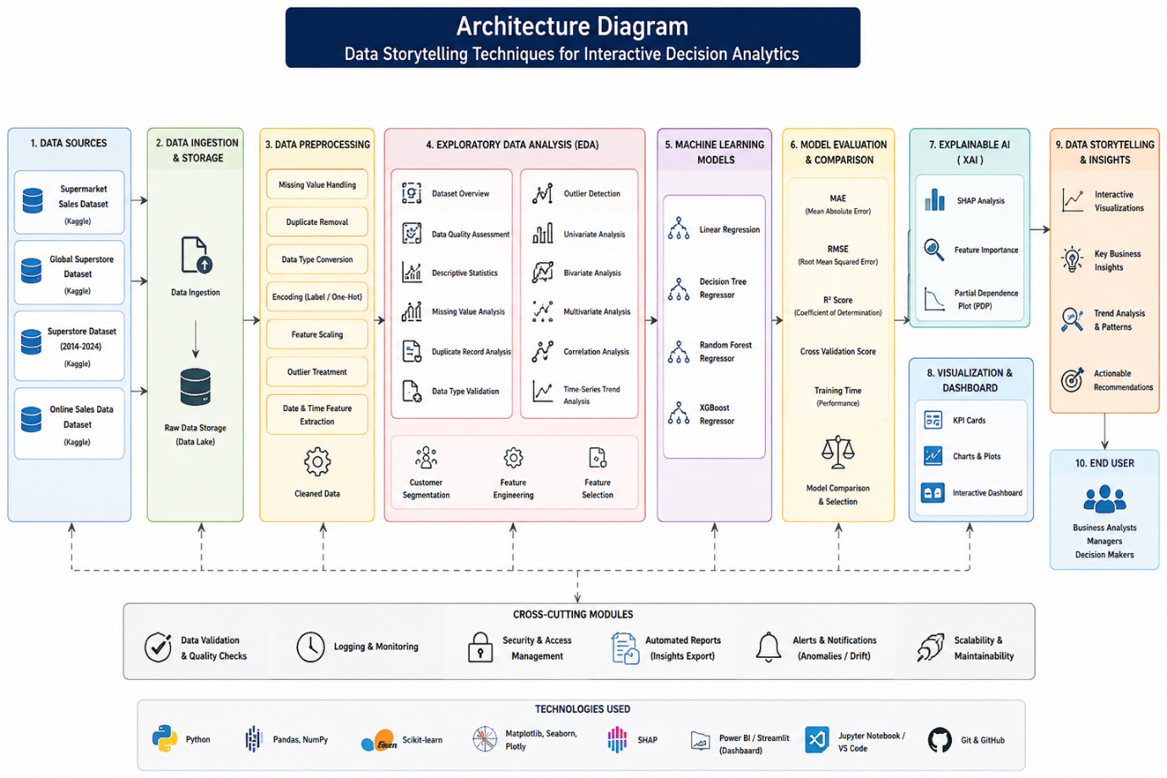

TOOLS:
Python, Flask, HTML, CSS, JavaScript, Jupyter Notebook, Pandas, NumPy, Matplotlib, Plotly, Power BI, Git, GitHub, Visual Studio Code (VS Code), Datasets.

Expected Final System

A web-based interactive data analytics and storytelling platform that processes supermarket sales data, performs data cleaning and exploratory analysis, and applies data storytelling techniques such as trend analysis, comparison analysis, KPI storytelling, drill-down analysis, interactive filtering, and customer behavior analysis. The system generates interactive visualizations and presents key sales, customer, and product insights through an interactive Power BI/dashboard interface. It helps users identify trends, compare business performance, explore customer behavior, and make data-driven business decisions through clear and interactive data stories.

